VPC Task – 02

- Create one VPC, with 1 public subnet and 1 private subnet.
Go to VPC Console → Your VPCs → Create VPC
Name: my-vpc
CIDR block: 10.0.0.0/16
Tenancy: Default → Create
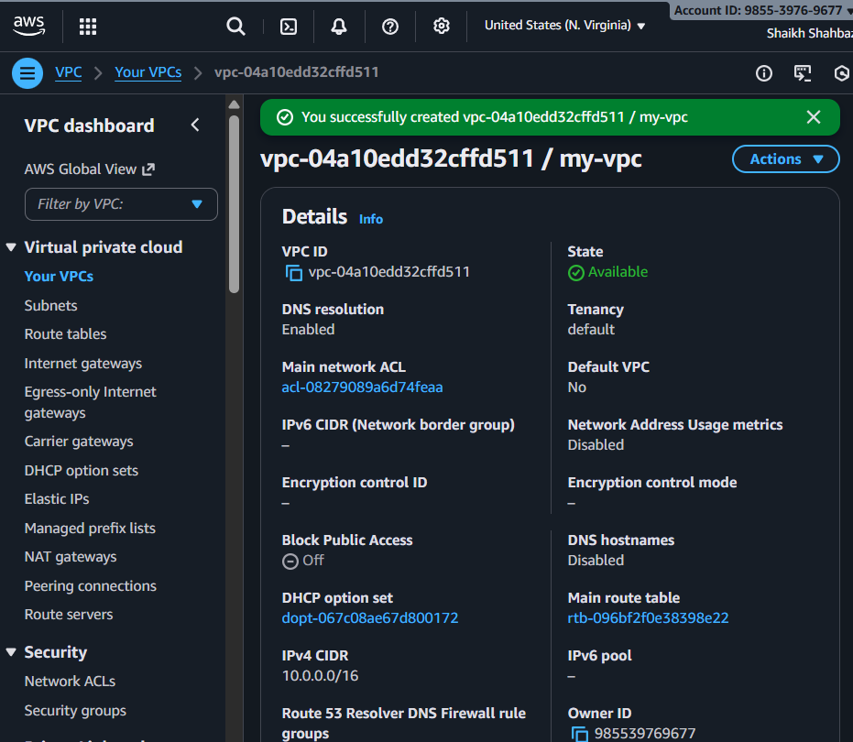
Create Subnets
Go to Subnets → Create subnet
VPC: my-vpc
AZ: choose any
Name: public-subnet
CIDR: 10.0.1.0/24
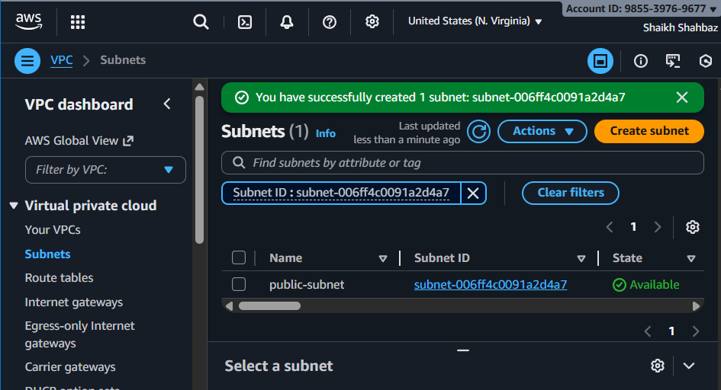
Create another subnet:
Name: private-subnet
CIDR: 10.0.2.0/24
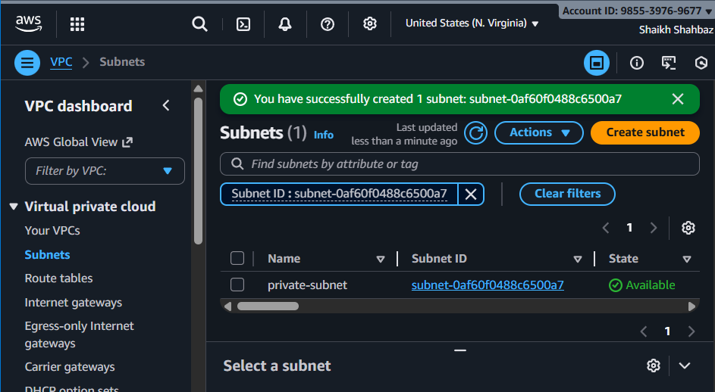
Public Subnet → Assign auto-assign Public IP
Select public-subnet → Edit subnet settings
Enable Auto-assign IPv4 public IP
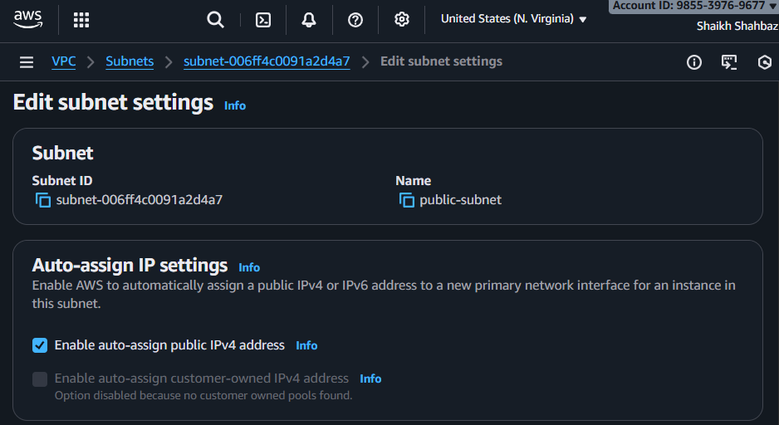
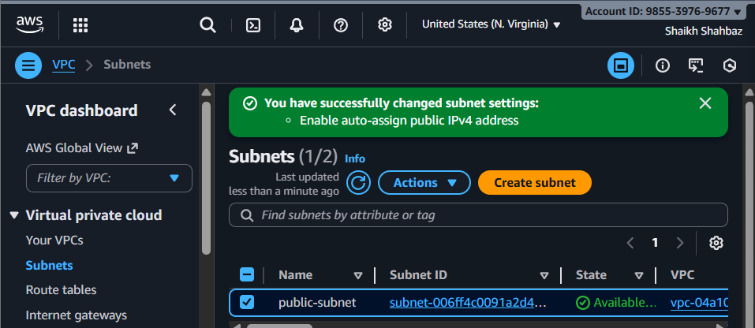
Create Internet Gateway
Go to Internet Gateways → Create IGW
Name: my-igw
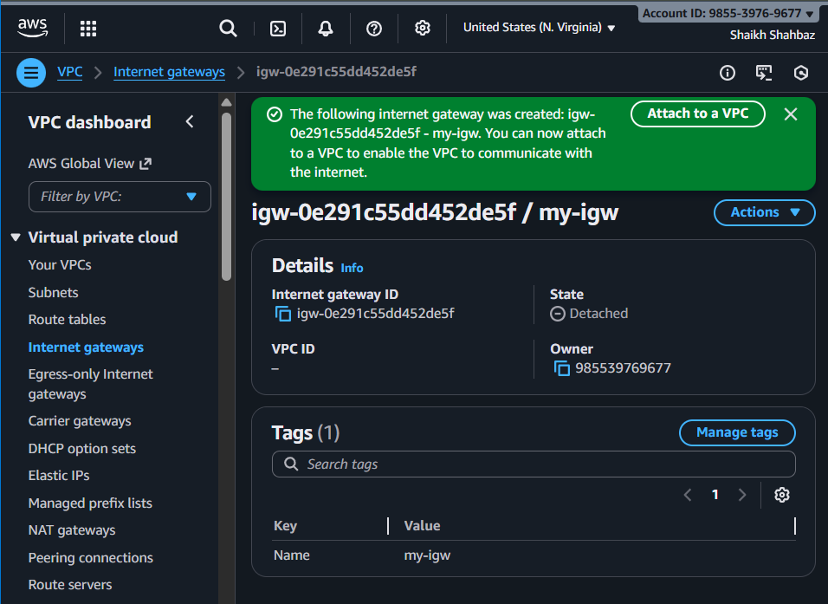
Attach to my-vpc
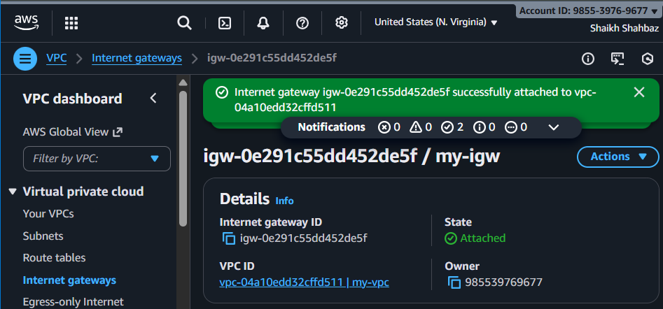
Route Table updates
Public route table:
Go to Route tables
Create route table public-rt for my-vpc

Add a route: 0.0.0.0/0 → Internet Gateway
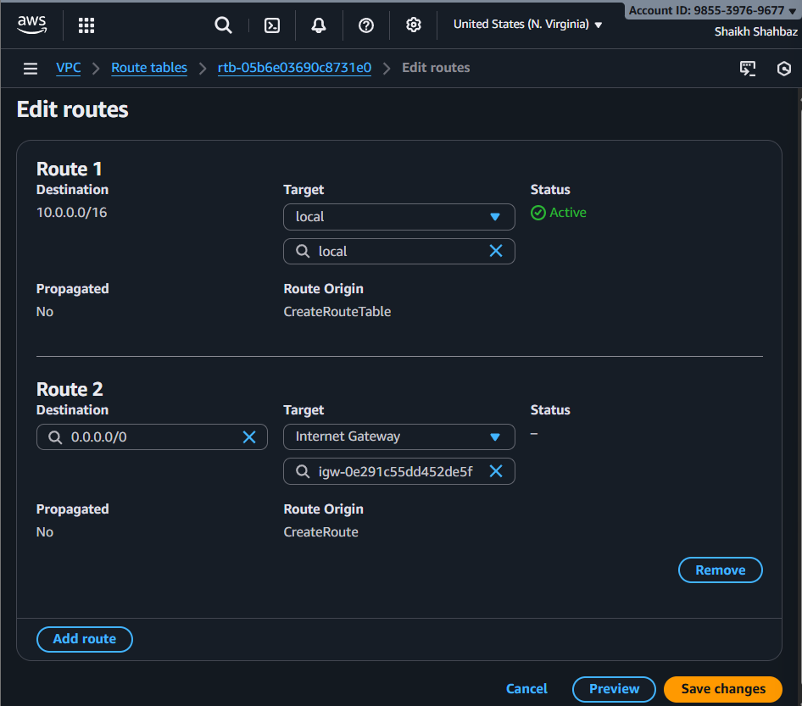
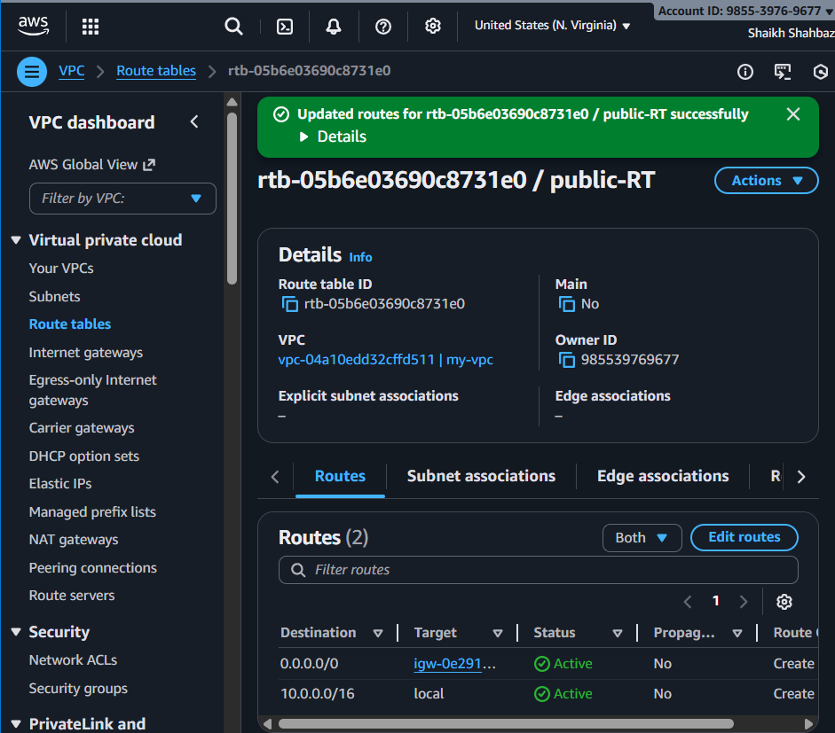
Associate with public-subnet
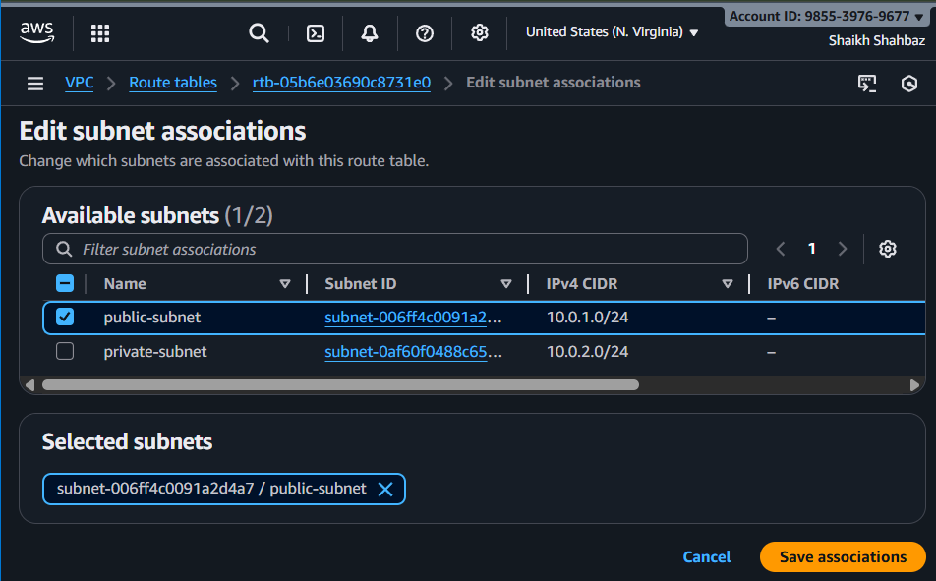

Private route table:
Create private-rt
No public route (keeps subnet private)
Associate with private-subnet
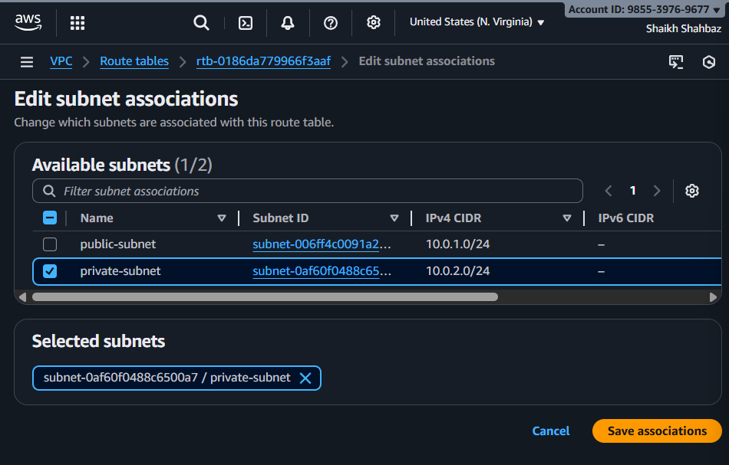

- Enable VPC peering for cross-region.
Steps
Assume my-vpc-01 (N.Virginia)
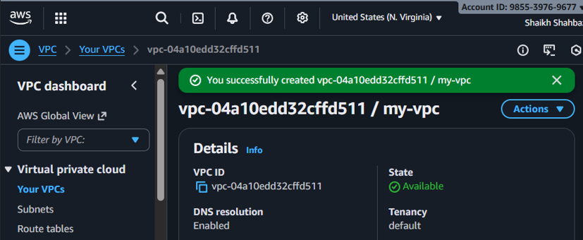

and my-vpc-02 (Ohio).
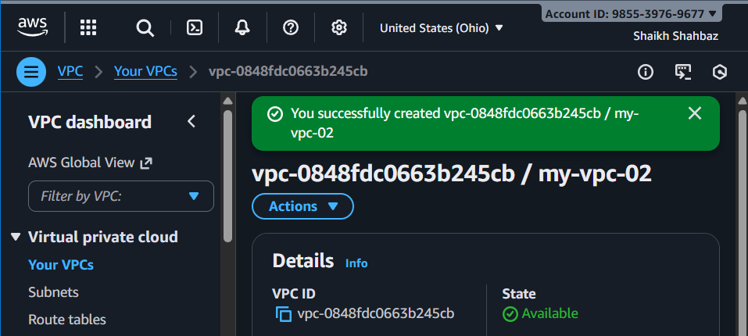
- Go to VPC Peering → Create Peering Connection
  - Name: peer-ap-to-us
  - Requester VPC: VPC-A (ap-south-1)
  - Accepter VPC: VPC-B (us-east-1)
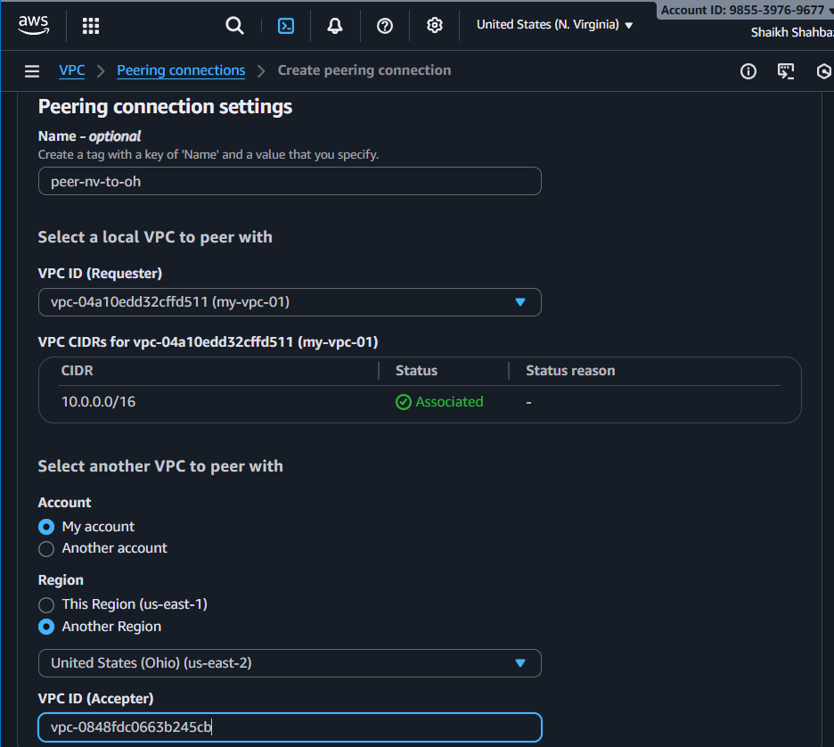
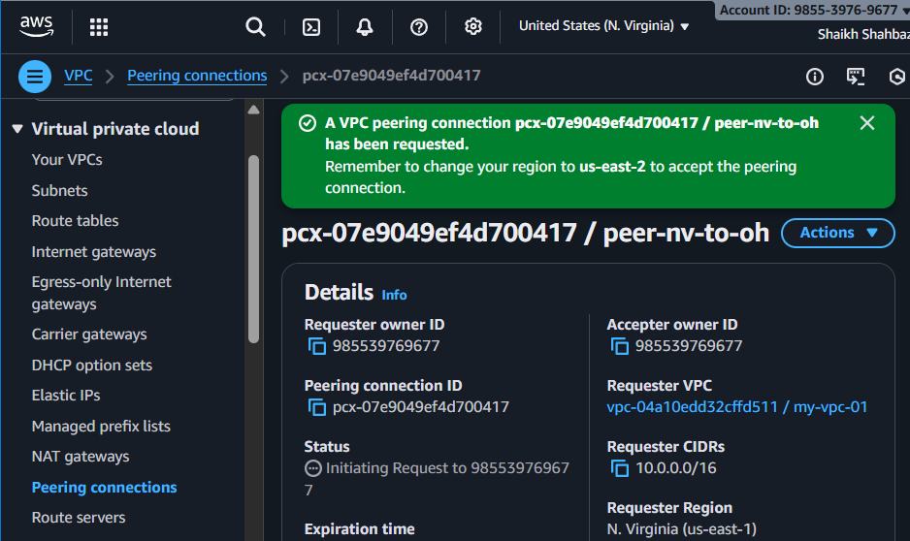
- Go to VPC-B → Peering requests
  - Accept request
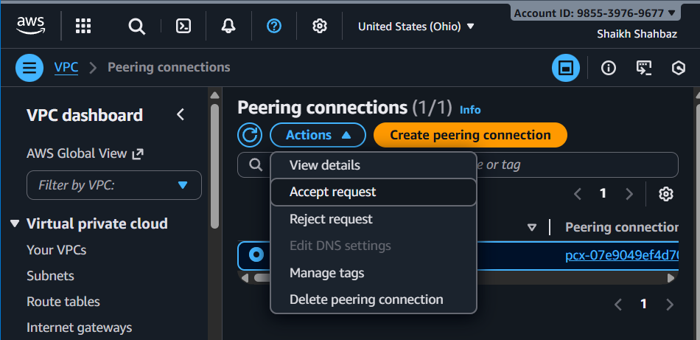
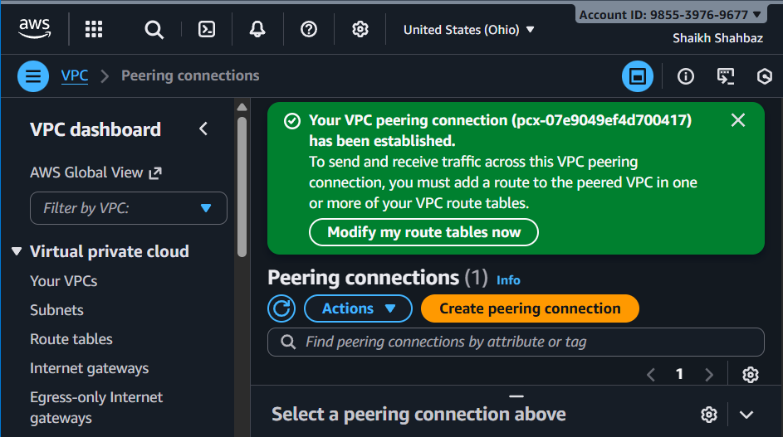

- Update Route Tables
  - In my-vpc-01 route table:
    - Destination: CIDR of my-vpc-02 → Target: Peering Connection
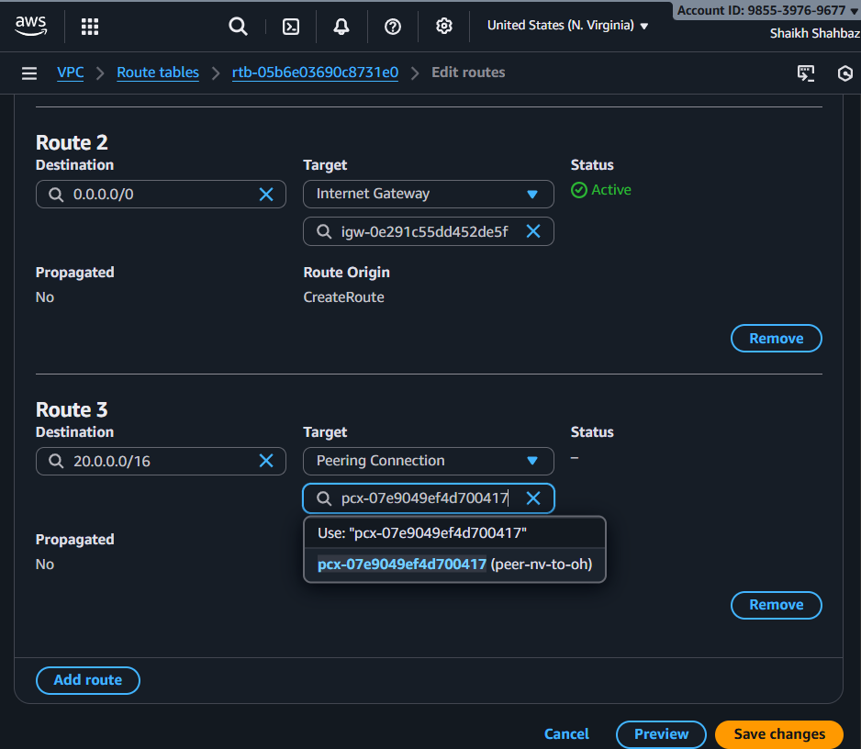

  - In my-vpc-02 route table:
    - Destination: CIDR of my-vpc-01 → Target: Peering Connection
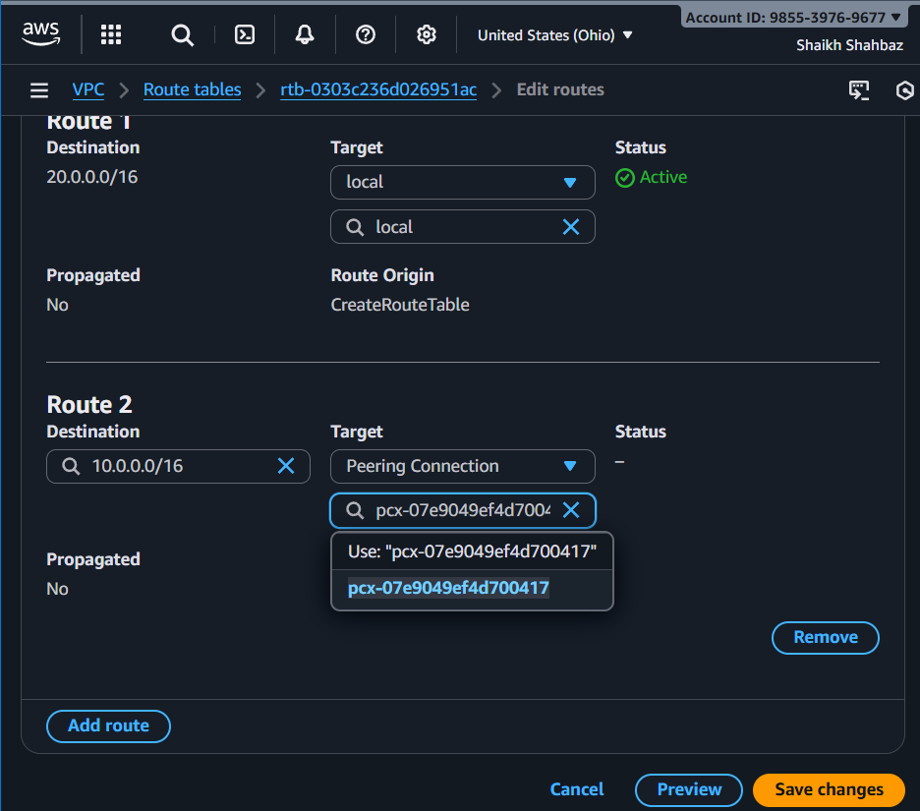

- Enable VPC peering for cross-account (you can collaborate with your friend to do this task).

Pre-requisites
Your account: VPC-A CIDR 172.31.0.0/16
Friend’s account: VPC-B CIDR 10.0.0.0/16

Steps

- You create peering request:
  - VPC Peering → Create Peering Connection
  - Requester: Your VPC
  - Accepter:
    - Account ID: Friend's AWS Account
    - Region: same or different region
    - VPC ID: Friend's VPC
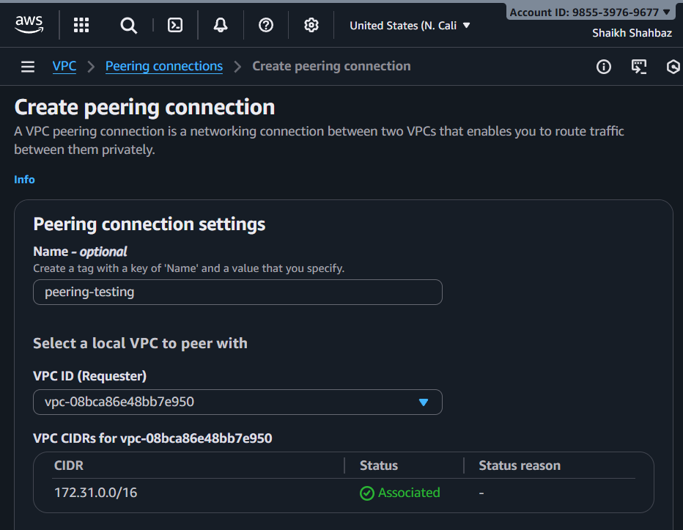
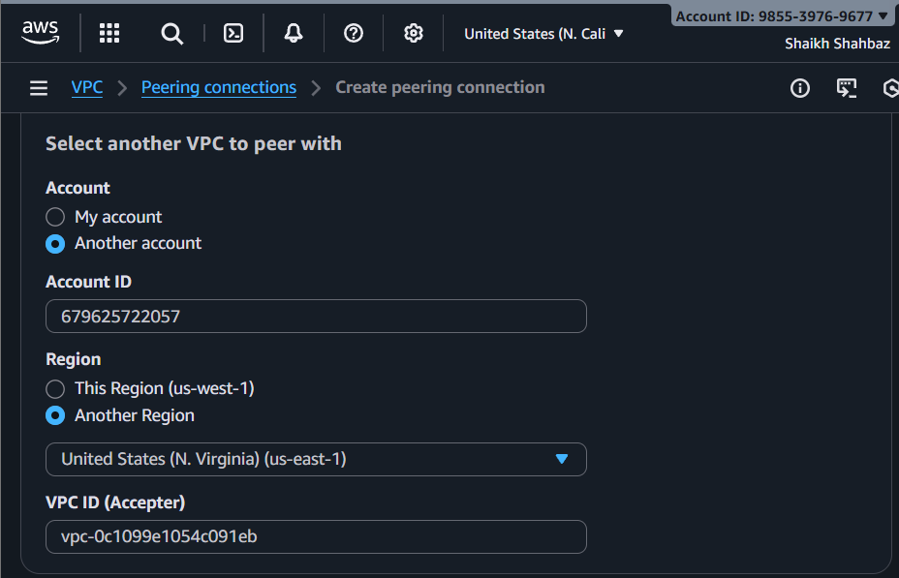
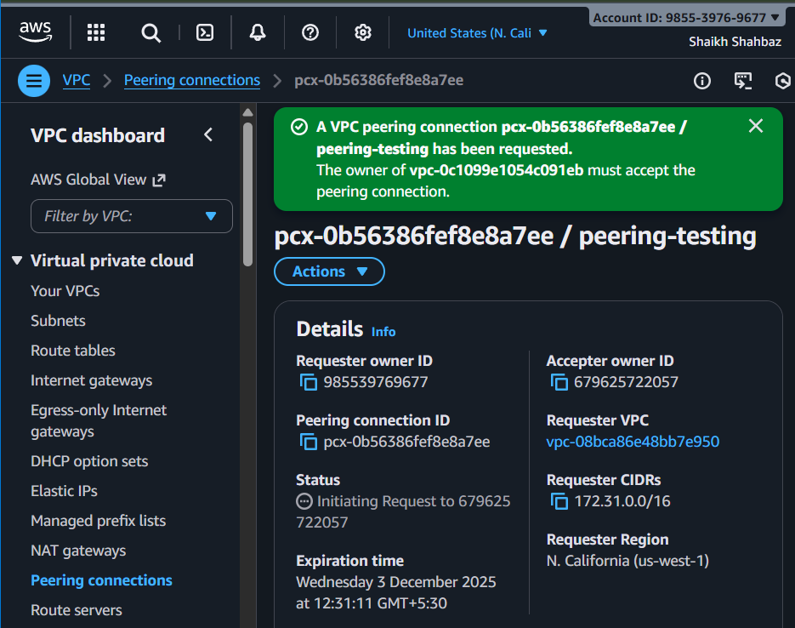

- Friend accepts request
  - VPC Console → Peering requests → Accept
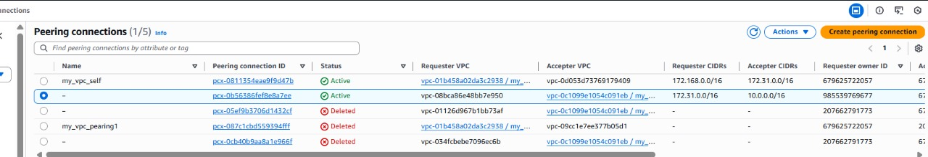

- Both update Route tables
  - VPC-A route table → 172.31.0.0/16 → Peering connection
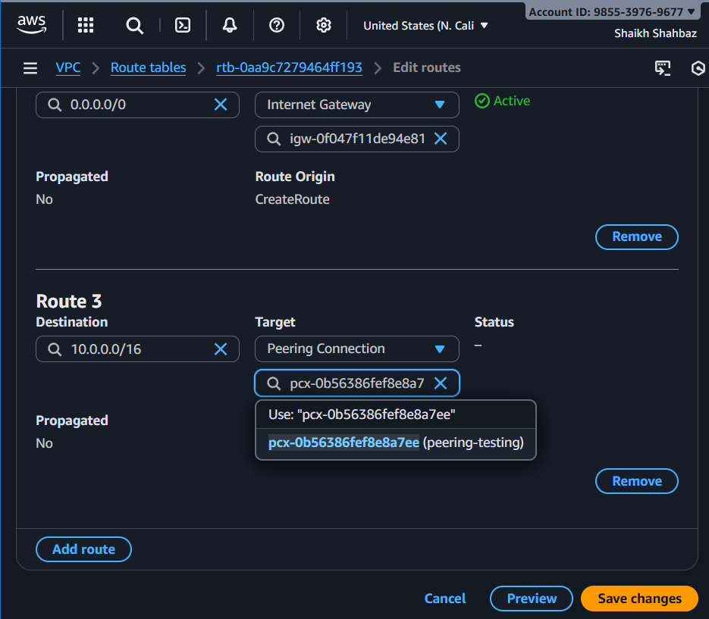

  - VPC-B route table → 10.0.0.0/16 → Peering connection
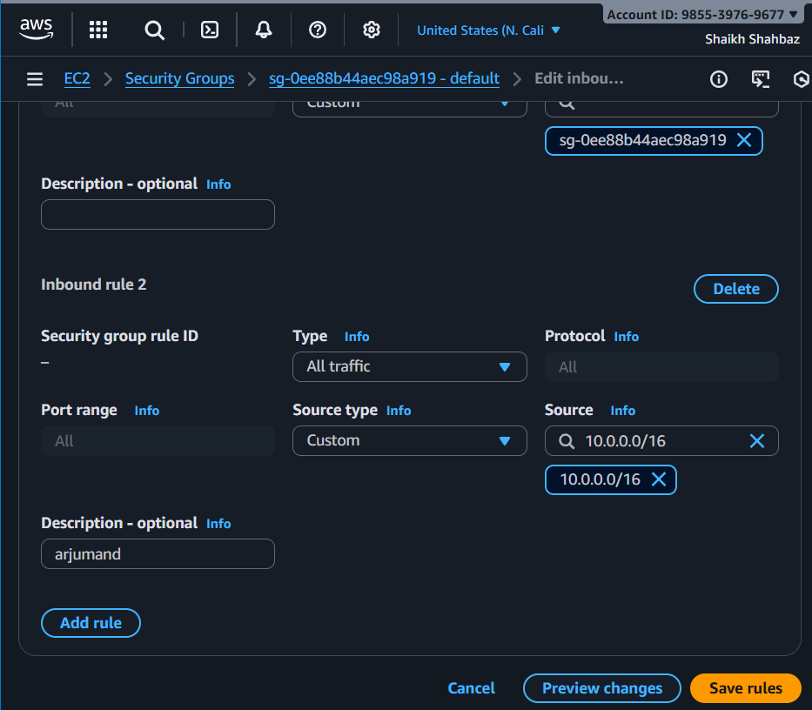
Now connect to your ec2 <n.california-ec2>
sudo su –
ping <friends-private-ip>
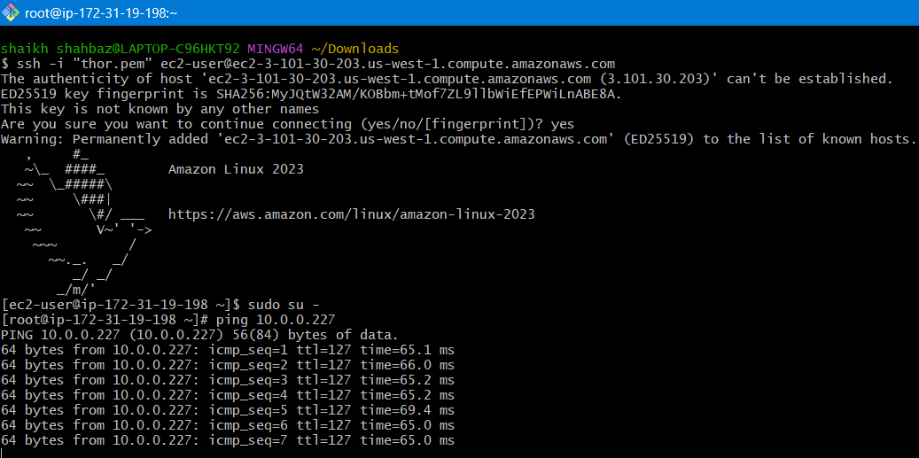
Checked with Friends ec2 connected successfully
ping <my-private-id>
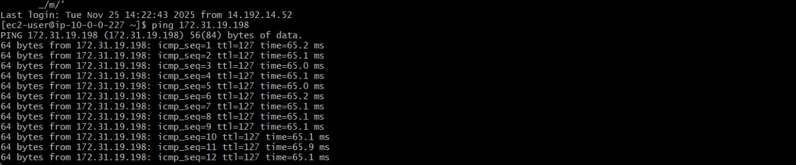

- Set up a VPC Transit Gateway.

Steps
Create 3 -VPCs : my-vpc-01 -----(10.0.0.0/24)
my-vpc-02 -----(10.0.1.0/24)
my-vpc-03 -----(10.0.2.0/24)
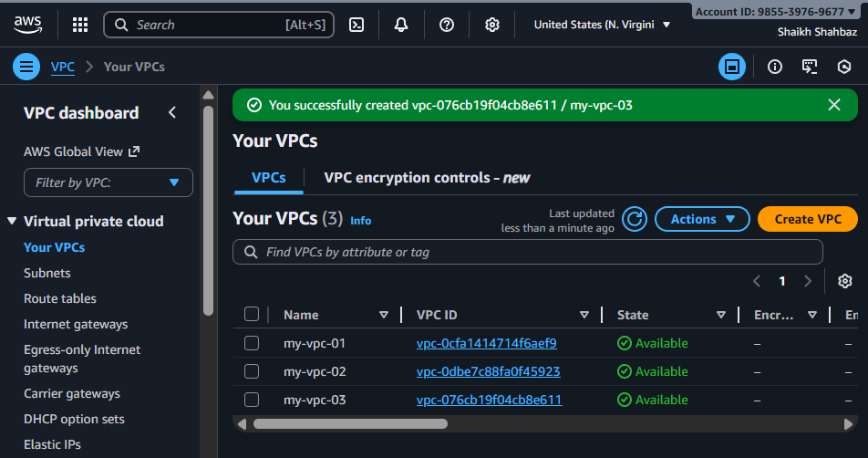

Create 3-Subnets : subnet-01 subnet-02 subnet-03
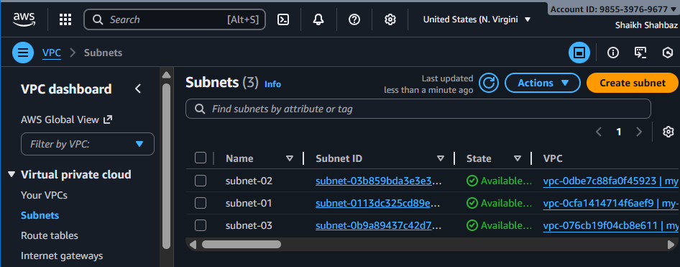

- Go to Transit Gateways → Create transit gateway
  - Name: my-tgw
  - ASN default fine → Create
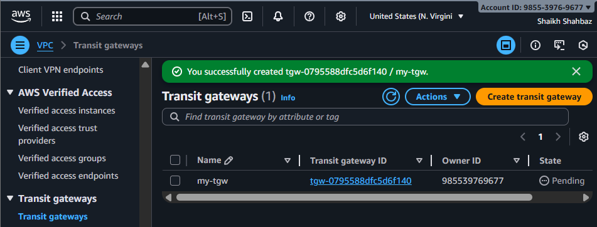
- Add TGW attachments
For each VPC:
  - Transit Gateway Attachments → Create attachment
  - Attachment type: VPC
  - Select VPC + Subnets required
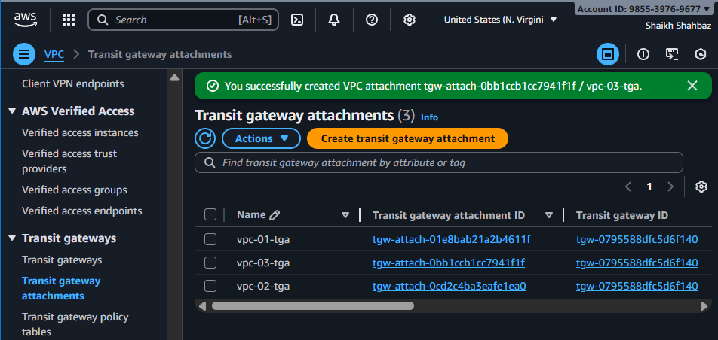

Launch 3 – Instances in public-ec2 : ec2-vpc-01 ec2-vpc-02 ec2-vpc-03
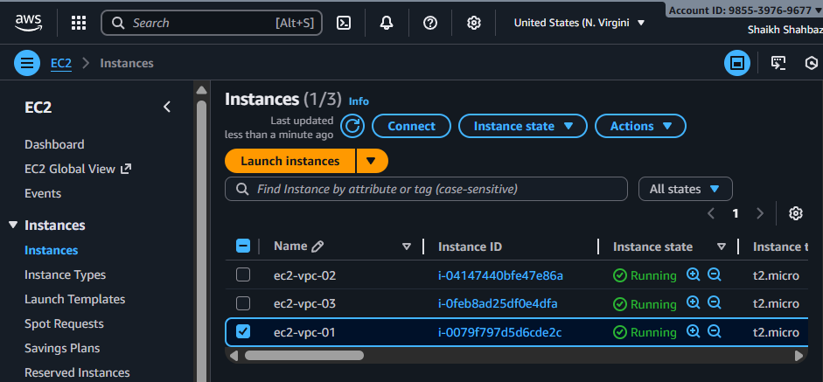

- Route Tables
  - TGW creates its own route table
  - Add routes to allow VPC CIDRs
  - In each VPC route table:
    - Add route → CIDR of other VPCs → Transit Gateway
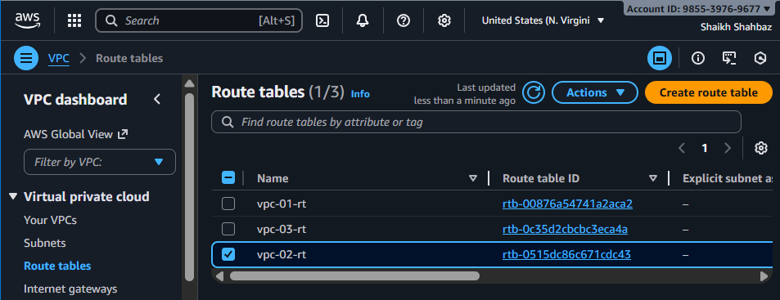
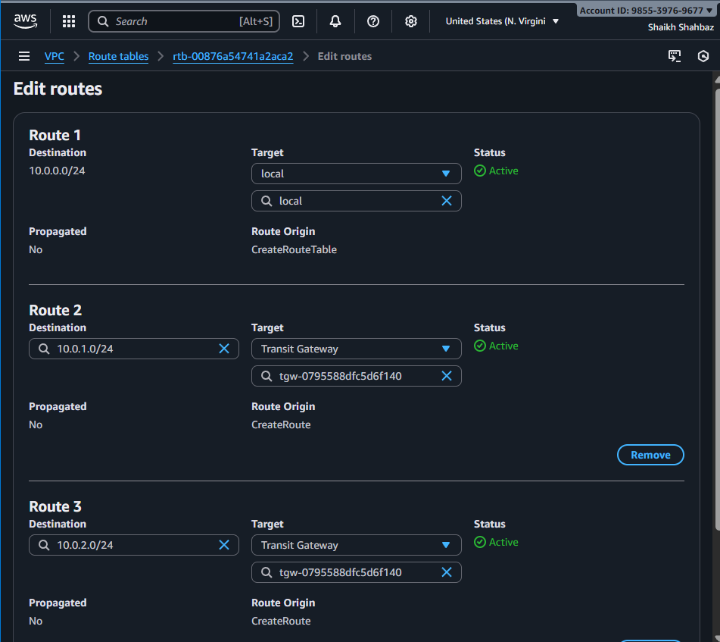

Create Internet Gateway : vpc-01-igw vpc-02-igw vpc-03-igw
Attach to the respective VPCs
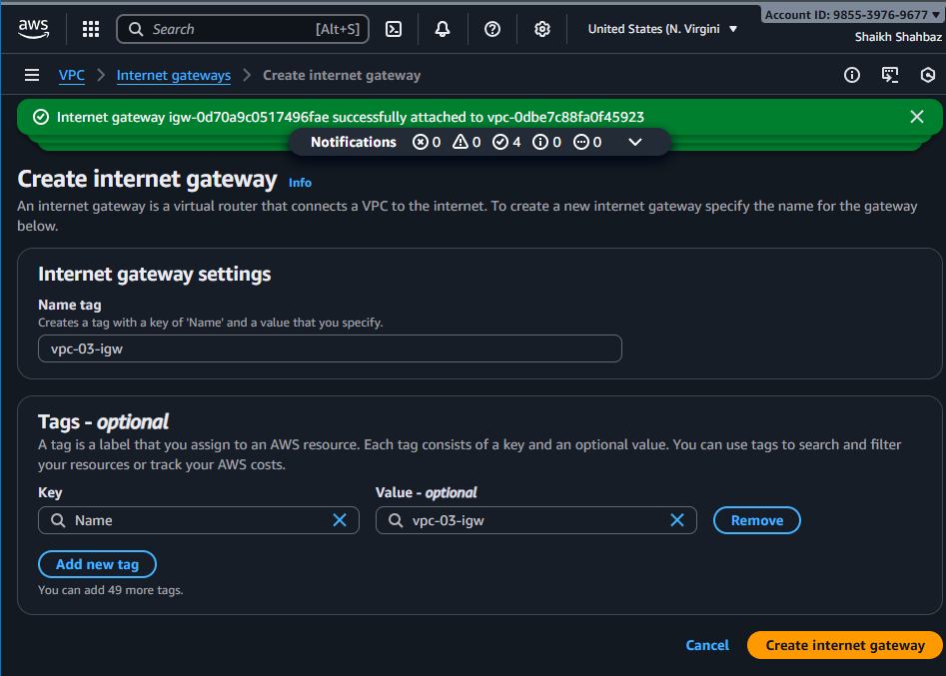
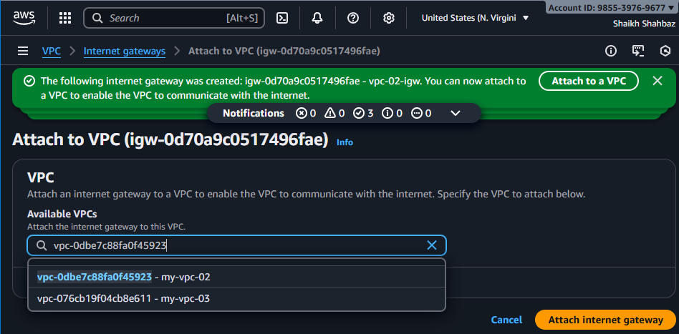
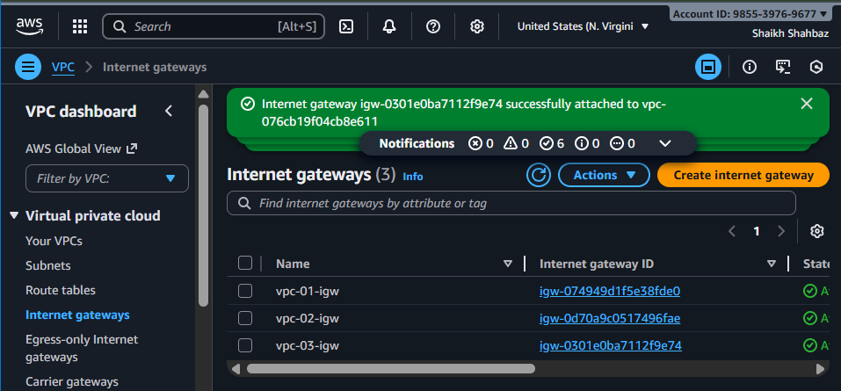
Add Internet Gateway to the Route Tables for each of them ----All – 3
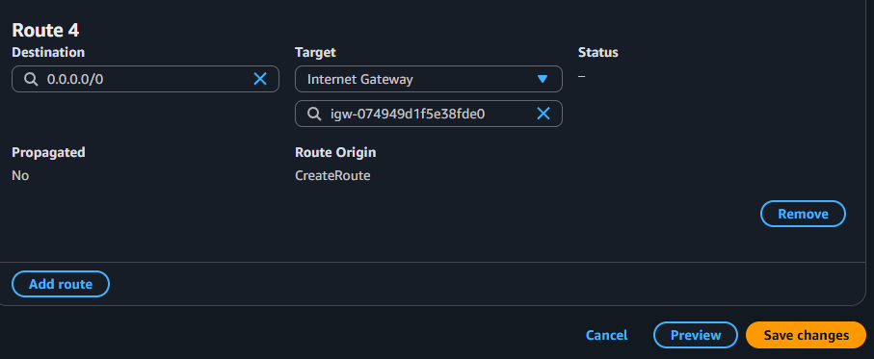
Now we can access any ec2 with its public-ip
I have connected to ec2-vpc-01 instance and ping <private-ip> of ec2-vpc-03
Its connected successfully
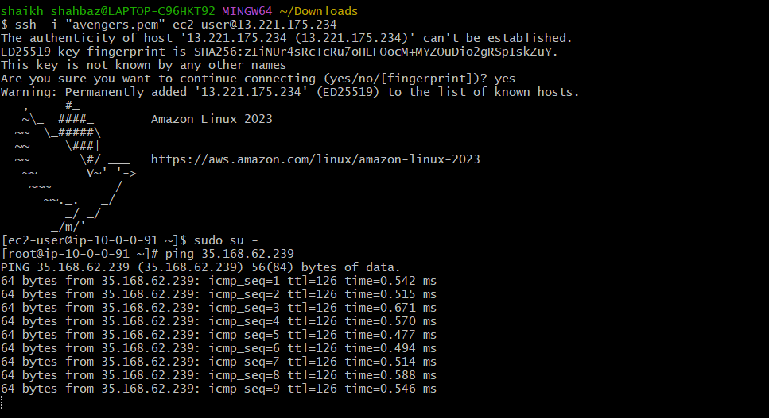

- Set up a VPC Endpoint.
Allows private access to AWS services without Internet.
Steps
- Go to VPC Endpoints → Create Endpoint
- Choose AWS Service — Example:
  - com.amazonaws.<region>.s3
- Type:
  - Gateway endpoint → for S3 - bucket
  - Interface endpoint → for other services (SNS, SQS, etc.)
- Select your VPC + Route tables (for gateway) or Subnets + SG (for interface)
- DNS enabled → Yes
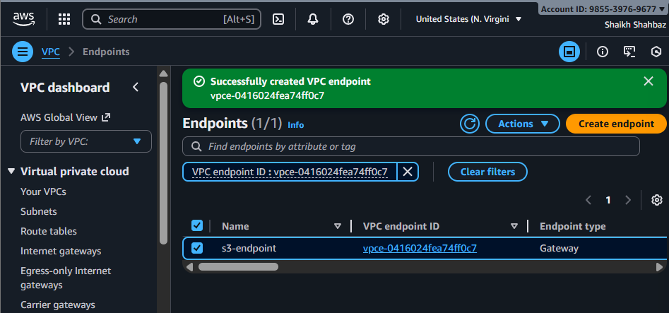
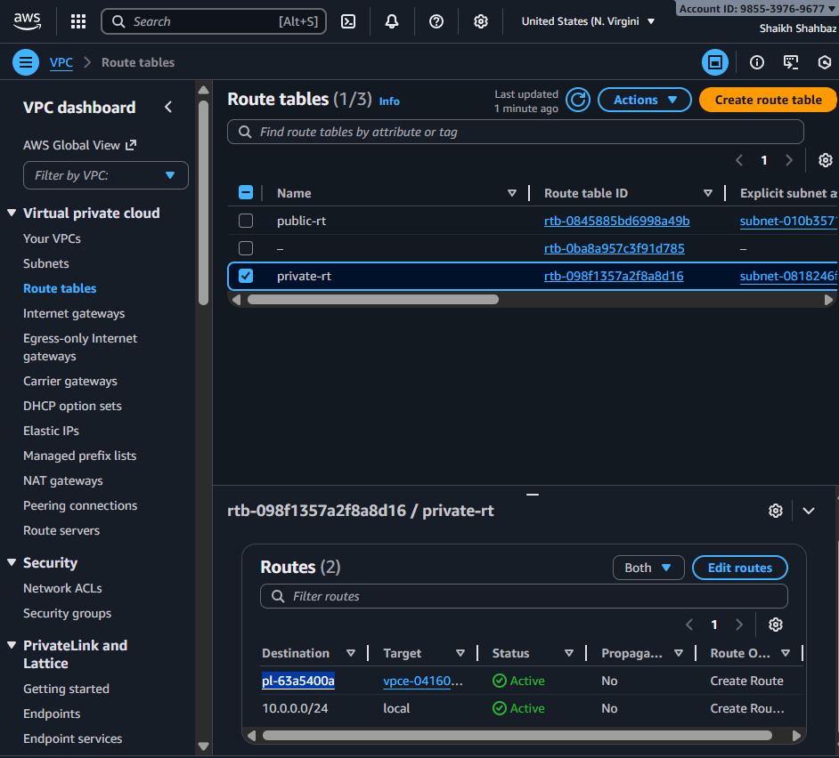
After creation:
- EC2 inside private subnet can access AWS services without NAT Gateway / public internet.
- By using ssh -I avengers.pem ec2-user@<private-ec2-private-ip>
- From public-ec2 to private-ec2 by using <private-ip>
